**School of Science, Computing, and Engineering Technologies**

**ENG10004**

**Digital and Data Systems**

# Portfolio

Student Name: HONG HAI DANG NGUYEN

Student ID: 103503191

Date: 24/04/2022

Self-Assessment Details

The following checklists provide an overview of my self-assessment for this portfolio.

|  |  |  |  |  |  |
| --- | --- | --- | --- | --- | --- |
|  | **Fail** | **Pass** | **Credit** | **Distinction** | **High Distinction** |
| Self-Assessment (**please tick** ✓) |  |  |  |  | ✓ |

**Tick (✓) the tasks** included and signed-off in this portfolio.

*Pass Borderline Tasks Checklist:*

|  |  |  |  |  |  |  |
| --- | --- | --- | --- | --- | --- | --- |
| **Pass Borderline Tasks** | **PB1** | **PB2** | **PB3** | **PB4** | **PB5** | **PB6** |
| Included | ✓ | ✓ | ✓ | ✓ | ✓ | ✓ |
| Submit in due time for feedback | ✓ | ✓ | ✓ | ✓ | ✓ | ✓ |

*Pass Plus Tasks Checklist:*

|  |  |  |
| --- | --- | --- |
| **Pass Plus Task** | **PP1** | **PP2** |
| Included | ✓ | ✓ |
| Get feedback | ✓ | ✓ |

*Credit Tasks Checklist:*

|  |  |  |
| --- | --- | --- |
| **Credit Task** | **C1** | **C2** |
| Included | ✓ | ✓ |
| Get feedback | ✓ | ✓ |

*Distinction Tasks Checklist:*

|  |  |  |
| --- | --- | --- |
| **Distinction Tasks** | **D1** | **D2** |
| Included | ✓ | ✓ |
| Get feedback | ✓ | ✓ |

*High Distinction Task Checklist:*

|  |  |  |
| --- | --- | --- |
| **High Distinction Task** | **HD1** | **HD2** |
| Included | ✓ | ✓ |
| Get feedback | ✓ | ✓ |

# Declaration

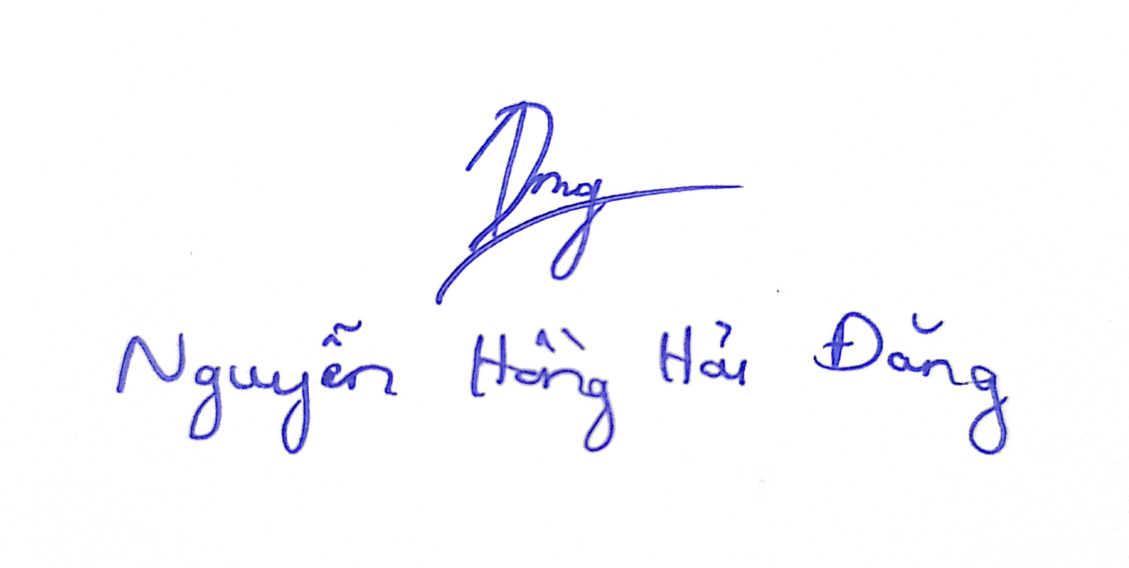I declare that this portfolio is my individual work. I have not copied from any other student’s work or from any other source except where due acknowledgment is made explicitly in the text, nor has any part of this submission been written for me by another person.

**Signature:**

Pass Borderline Task 1

Problem 1 solution:

1. >> a = 15

a =

15

1. >> b = 2.1e25

b =

2.1000e+25

1. >> c = 3 + 5i

c =

3.0000 + 5.0000i

Problem 2 solution:

1. >> x = 3/(1+exp(-(a-9)/5))

x =

2.3056

1. >> y = (sqrt(a)+b^(1/3))^pi

y =

3.2913e+26

1. >> z = tan(real(c)) + sin(pi/5)^2

z =

0.2029

1. >> w = log(abs(a^(2.5)-1010))

w =

4.9314

Problem 3 solution:

1. >> aVec = [16 3.14 7 21]

aVec =

16.0000 3.1400 7.0000 21.0000

1. >> bVec = [2.51;5;27;160]

bVec =

2.5100

5.0000

27.0000

160.0000

1. >> cVec = [3:-0.5:0.5]

cVec =

3.0000 2.5000 2.0000 1.5000 1.0000 0.5000

1. >> dVec = [10^0.01 log(49) 977 sqrt(a)]'

dVec =

1.0233

3.8918

977.0000

3.8730

1. >> eVec = 'Hello Swinburne!'

eVec =

'Hello Swinburne!'

Problem 4 solution:

1. >> xVec = (1/sqrt(2*pi)) * exp(-cVec.^2/2.5)

xVec =

0.0109 0.0327 0.0805 0.1622 0.2674 0.3610

1. >>yVec = sqrt((aVec').^2+bVec.^2)

yVec =  
 16.1957  
 5.9042  
 27.8927  
 161.3722

1. >> zVec = log10(2./dVec)

zVec =

0.2910

-0.2891

-2.6889

-0.2870

Problem 5 solution:

>> Value = 123.4567e2

Value =

1.2346e+04

>> fprintf('Value = %e\n', Value)

This will display the value in exponential format in a new line.

Value = 1.234567e+04

>> fprintf('Value = %f\n', Value)

This will display the value in floating point format in a new line.

Value = 12345.670000

>> fprintf('Value = %g\n', Value)

This will display the value in a more compact floating point format in a new line.

Value = 12345.7

>> fprintf('Value = %12.4f\n', Value)

This will display the value in floating point format in a new line. The %12.4f indicates that the first data item in the function should be printed out in floating point format in a field of 12 characters wide, including 4 digits after decimal point.

Value = 12345.6700

Pass Borderline Task 2

Problem 1 solution:

1. >> aMat = [1 -4; 3 6]

aMat =

1. -4

3 6

1. >> bMat = 3*ones(3,4)

bMat =

3 3 3 3

3 3 3 3

3 3 3 3

1. >> cMat = [aMat aMat; aMat aMat]

cMat =

1 -4 1 -4

3 6 3 6

1 -4 1 -4

3 6 3 6

1. >> dMat = [12:2:18; [4 3 6 8]; zeros(1,2) 4 9; -1:-3:-10]

dMat =

12 14 16 18

4 3 6 8

0 0 4 9

-1 -4 -7 -10

Problem 2 solution:

1. >> xMat = aMat^2

xMat =

-11 -28

21 24

1. >> yMat = aMat.^2

yMat =

1. 16

9 36

Explain: The “^2” in 1) indicates the matrix exponentiation; in other word, it is the multiplication of aMat with aMat. The “.^2” in 2) however indicates the array exponentiation, which is the element-by-element exponentiation of aMat and 2.

1. >> zMat = cMat’ + inv(dMat)

zMat =

1.0699 3.1250 1.1250 3.3382

-3.7426 5.2500 -3.7500 6.0882

0.5699 4.1250 0.1250 2.3382

-3.8088 5.5000 -3.5000 6.2941

Problem 3 solution:

1. >> size(aMat)

ans =

2 2

aMat has 1 row and 2 columns

1. >> bMat(1, :) = [1 1 1 1]

bMat =

1 1 1 1

3 3 3 3

3 3 3 3

1. >> cMat(:,2)

ans =

-4

6

-4

6

1. >> dMat(1:3,2:4)

ans =

14 16 18

3 6 8

0 4 9

Problem 4 solution:

Overall, the set of statements is used to calculate the area and perimeter of a circle based on the input radius. In detail:

* radius = input(‘Enter the circle radius:\n’): Display the sentence “Enter the circle radius:” and the user will fill in the value they want.
* Area = pi*radius^2: Calculate the circle area.
* Perimeter = 2*pi*radius: Calculate the circle perimeter.
* fprintf(‘The area is %f \n’, Area): Print out the sentence “The area is” and the calculated area.
* 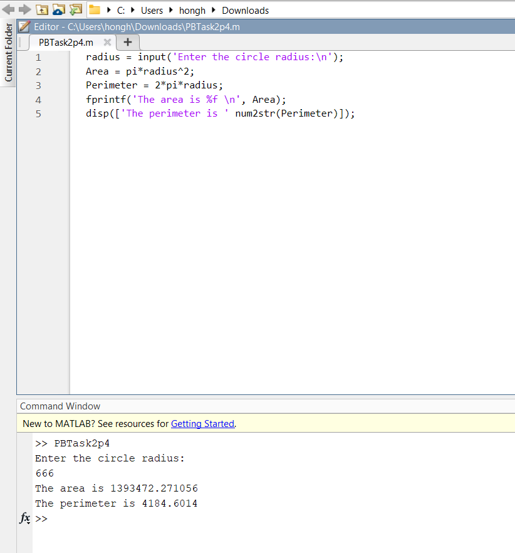disp([‘The perimeter is ‘ num2str(Perimeter)]): Print out the sentence “The perimeter is” and the calculated perimeter

Problem 5 solution:

t = 0:pi/100:2*pi;

y_1 = sin(t);

y_2 = cos(t);

figure = figure(1);

plot(t, y_1);

hold on;

plot(t, y_2,LineStyle='--',Color='r');

hold off;

xlim([0 2*pi]);

ylim([-1.4 1.4]);

xlabel('Time (s)');

ylabel('Function value');

title('Sin and Cos functions');

legend('sin','cos');

Pass Borderline Task 3

Problem 1 solution:

1. Identifying the errors
   1. Syntax errors:

* Line 6: The multiplication of v0 and t is missing the multiplication sign ' * ’.
* Line 10: Incorrect use of the function fprintf as only “fprint” was typed (i.e., missing the letter f at the end).
* Line 10: Missing the closing quote for the string “The position of the ball is: %f m.\n”.
  1. Logical errors:
* Line 4: Incorrect value of a. It should be -9.8
* Line 7: According to the given formula, it should be t^2 instead of t^3.
* Line 9: According to the given formula, it should be the sum of x1 and x2.

1. The correct program should be:

t=6;

x0=90;

v0=17;

a=-9.81;

x1=x0+v0*t;

x2=1/2*a*t^2;

x=x1+x2;

fprintf('The position of the ball is: %f m.\n',x)

The position of the ball is: 15.42 m.

Problem 2 solution:

h = input('Please enter the number of hours worked: ');

p = input('Please enter the hourly wage in $: ');

Pay = h * p;

if h > 40

Pay = Pay + (h - 40) * p * 0.6;

end

fprintf('The worker''s pay is $ %5.2f\n', Pay)

>> PBTask3p2

Please enter the number of hours worked: 30

Please enter the hourly wage in $: 20

The worker's pay is $ 600.00

>> PBTask3p2

Please enter the number of hours worked: 42

Please enter the hourly wage in $: 20

The worker's pay is $ 864.00

Problem 3 solution:

m = input('Please enter your m (0 - 100): ');

if m >= 80 && m <= 100

disp('Your grade is High Distinction');

elseif m >= 70 && m <80

disp('Your grade is Distinction');

elseif m >= 60 && m < 70

disp('Your grade is Credit');

elseif m >= 50 && m < 60

disp('Your grade is Pass');

elseif m >= 0 && m < 50

disp('Your grade is Fail');

else

disp('Your grade is Invalid');

end

>> PBTask3p3

Please enter your m (0 - 100): 55

Your grade is Pass

>> PBTask3p3

Please enter your m (0 - 100): 105

Your grade is Invalid

Problem 4 solution:

n = input('Please enter an integer number for n: ');

s = 0;

for k = 1:n

s = s + ((-2)^k * k^2)/((1.2)^(2*k+1));

end

fprintf('The result for n = %d is %4f\n', n, s)

>> PBTask3p4

Please enter an integer number for n: 8

The result for n = 8 is 473.856573

Problem 5 solution:

s = 0;

while s <= 9

n = randn(1);

if n <= 3

s = s + n;

else

break

end

end

fprintf('The sum of the random numbers is: %4f\n', s);

fprintf('The last random number generated is: %4f\n', n)

>> PPTask1p1

The sum of the random numbers is: -0.105012

The last random number generated is: 3.578397

Pass Borderline Task 4

Problem 1 solution:

function y = PBTask4p1_f(x)

y = 3.2 .* (x.^4) - 5.3 .* (x.^2) - 5.5 .* x;

end

clear all; clc;

y = PBTask4p1_f(-5);

y = PBTask4p1_f(4);

x = linspace(-5,5) ;

y = 3.2 .* x.^4 - 5.3 .* x.^2 - 5.5 .* x;

figure = figure(1);

plot(x,y,'b');

xlim([-5 5]);

ylim([-200 2000]);

xlabel('Input: x');

ylabel('Output: y')

y =

1895

y =

712.4000



Problem 2 solution:

function PBTask4p2a_f(count)

global COUNTER

count = input('Enter the Truck A count: ');

if COUNTER + count > 1000

COUNTER = 0;

else

COUNTER = COUNTER + count

end

function PBTask4p2b_f(count)

global COUNTER

count = input('Enter the Truck B count: ');

if COUNTER + count > 1000

COUNTER = 0;

else

COUNTER = COUNTER + count

end

>> global COUNTER;

>> COUNTER = 0;

>> PBTask4p2a_f(200)

COUNTER =

200

>> PBTask4p2b_f(600)

COUNTER =

800

>> PBTask4p2a_f(300)

COUNTER =

0

Problem 3 solution:

1. A = [0.21;0.52;0.71;-0.3;0.92;1.2;0.35];

fprintf("Vector A:\n");

disp(A);

fprintf("The Sum of vector A: %f",sum(A));

1. B = [0.24 57 -4; 0.13 65 -2.5; 0.28 55 -1; 0.21 45 -1.5; 0.32 56 -3; 0.45 58 0];

fprintf("\nVector B:\n");

disp(B);

fprintf("Mean of vector B\n");

fprintf("%f ",mean(B));

1. C = [1 0.3 -0.2 0.2 0.22 0.55 1.75 1.3 0.1 1.3];

fprintf("\nVector C:\n");

disp(C);

[M,I] = max(C);

fprintf("The maximum value in the vector C: %f and its first corresponding index: %d",M,I);

1. D = [8 1 3; 6 5 7; 4 9 2];

fprintf("\nVector D:\n");

disp(D);

I = find(D>5);

fprintf("Positions of elements greater than 5: ");

fprintf("%d ",I);

D(I) = 0;

fprintf("\nVector D after setting the index values to 0:\n");

disp(D);

>> PBTask4p3

Vector A:

0.2100

0.5200

0.7100

-0.3000

0.9200

1.2000

0.3500

The Sum of vector A: 3.610000

Vector B:

0.2400 57.0000 -4.0000

0.1300 65.0000 -2.5000

0.2800 55.0000 -1.0000

0.2100 45.0000 -1.5000

0.3200 56.0000 -3.0000

0.4500 58.0000 0

Mean of vector B

0.271667 56.000000 -2.000000

Vector C:

1.0000 0.3000 -0.2000 0.2000 0.2200 0.5500 1.7500 1.3000 0.1000 1.3000

The maximum value in the vector C: 1.750000 and its first corresponding index: 7

Vector D:

8 1 3

6 5 7

4 9 2

Positions of elements greater than 5: 1 2 6 8

Vector D after setting the index values to 0:

0 1 3

0 5 0

4 0 2

Problem 4 solution:

clc; clear all; close all;

d = daq.getDevices

s = daq.createSession('ni');

s.DurationInSeconds = 3; % Run for 3 seconds

s.Rate = 2000; % Sampling rate 2000 scans/sec

s.addAnalogInputChannel('myDAQ1','ai0', 'Voltage');

data = startForeground(s);

time = 1/2000*(0:length(data)-1);

plot(time,data);

xlabel('time (second)');

ylabel('sensor data (vol)');

1. At normal condition, the light intensity, acceleration and heart rate remain relatively consistant and not very rapid.
2. 
3. With the hand movement (i.e. the grabbing of the fingers), the measured signal becomes more rapid.



ni: National Instruments(TM) NI myDAQ (Device ID: 'myDAQ1')

Analog input supports:

-2.0 to +2.0 Volts,-10 to +10 Volts ranges

Rates from 0.1 to 200000.0 scans/sec

2 channels ('ai0','ai1')

'Voltage' measurement type

Analog output supports:

-2.0 to +2.0 Volts,-10 to +10 Volts ranges

Rates from 0.1 to 200000.0 scans/sec

2 channels ('ao0','ao1')

'Voltage' measurement type

Digital IO supports:

8 channels ('port0/line0' - 'port0/line7')

'InputOnly','OutputOnly','Bidirectional' measurement types

Counter input supports:

Rates from 0.1 to 100000000.0 scans/sec

1 channel ('ctr0')

'EdgeCount','PulseWidth','Frequency','Position' measurement types

Counter output supports:

Rates from 0.1 to 100000000.0 scans/sec

1 channel ('ctr0')

'PulseGeneration' measurement type

Pass Borderline Task 5

**Problem 1 + Problem 2 solutions:**

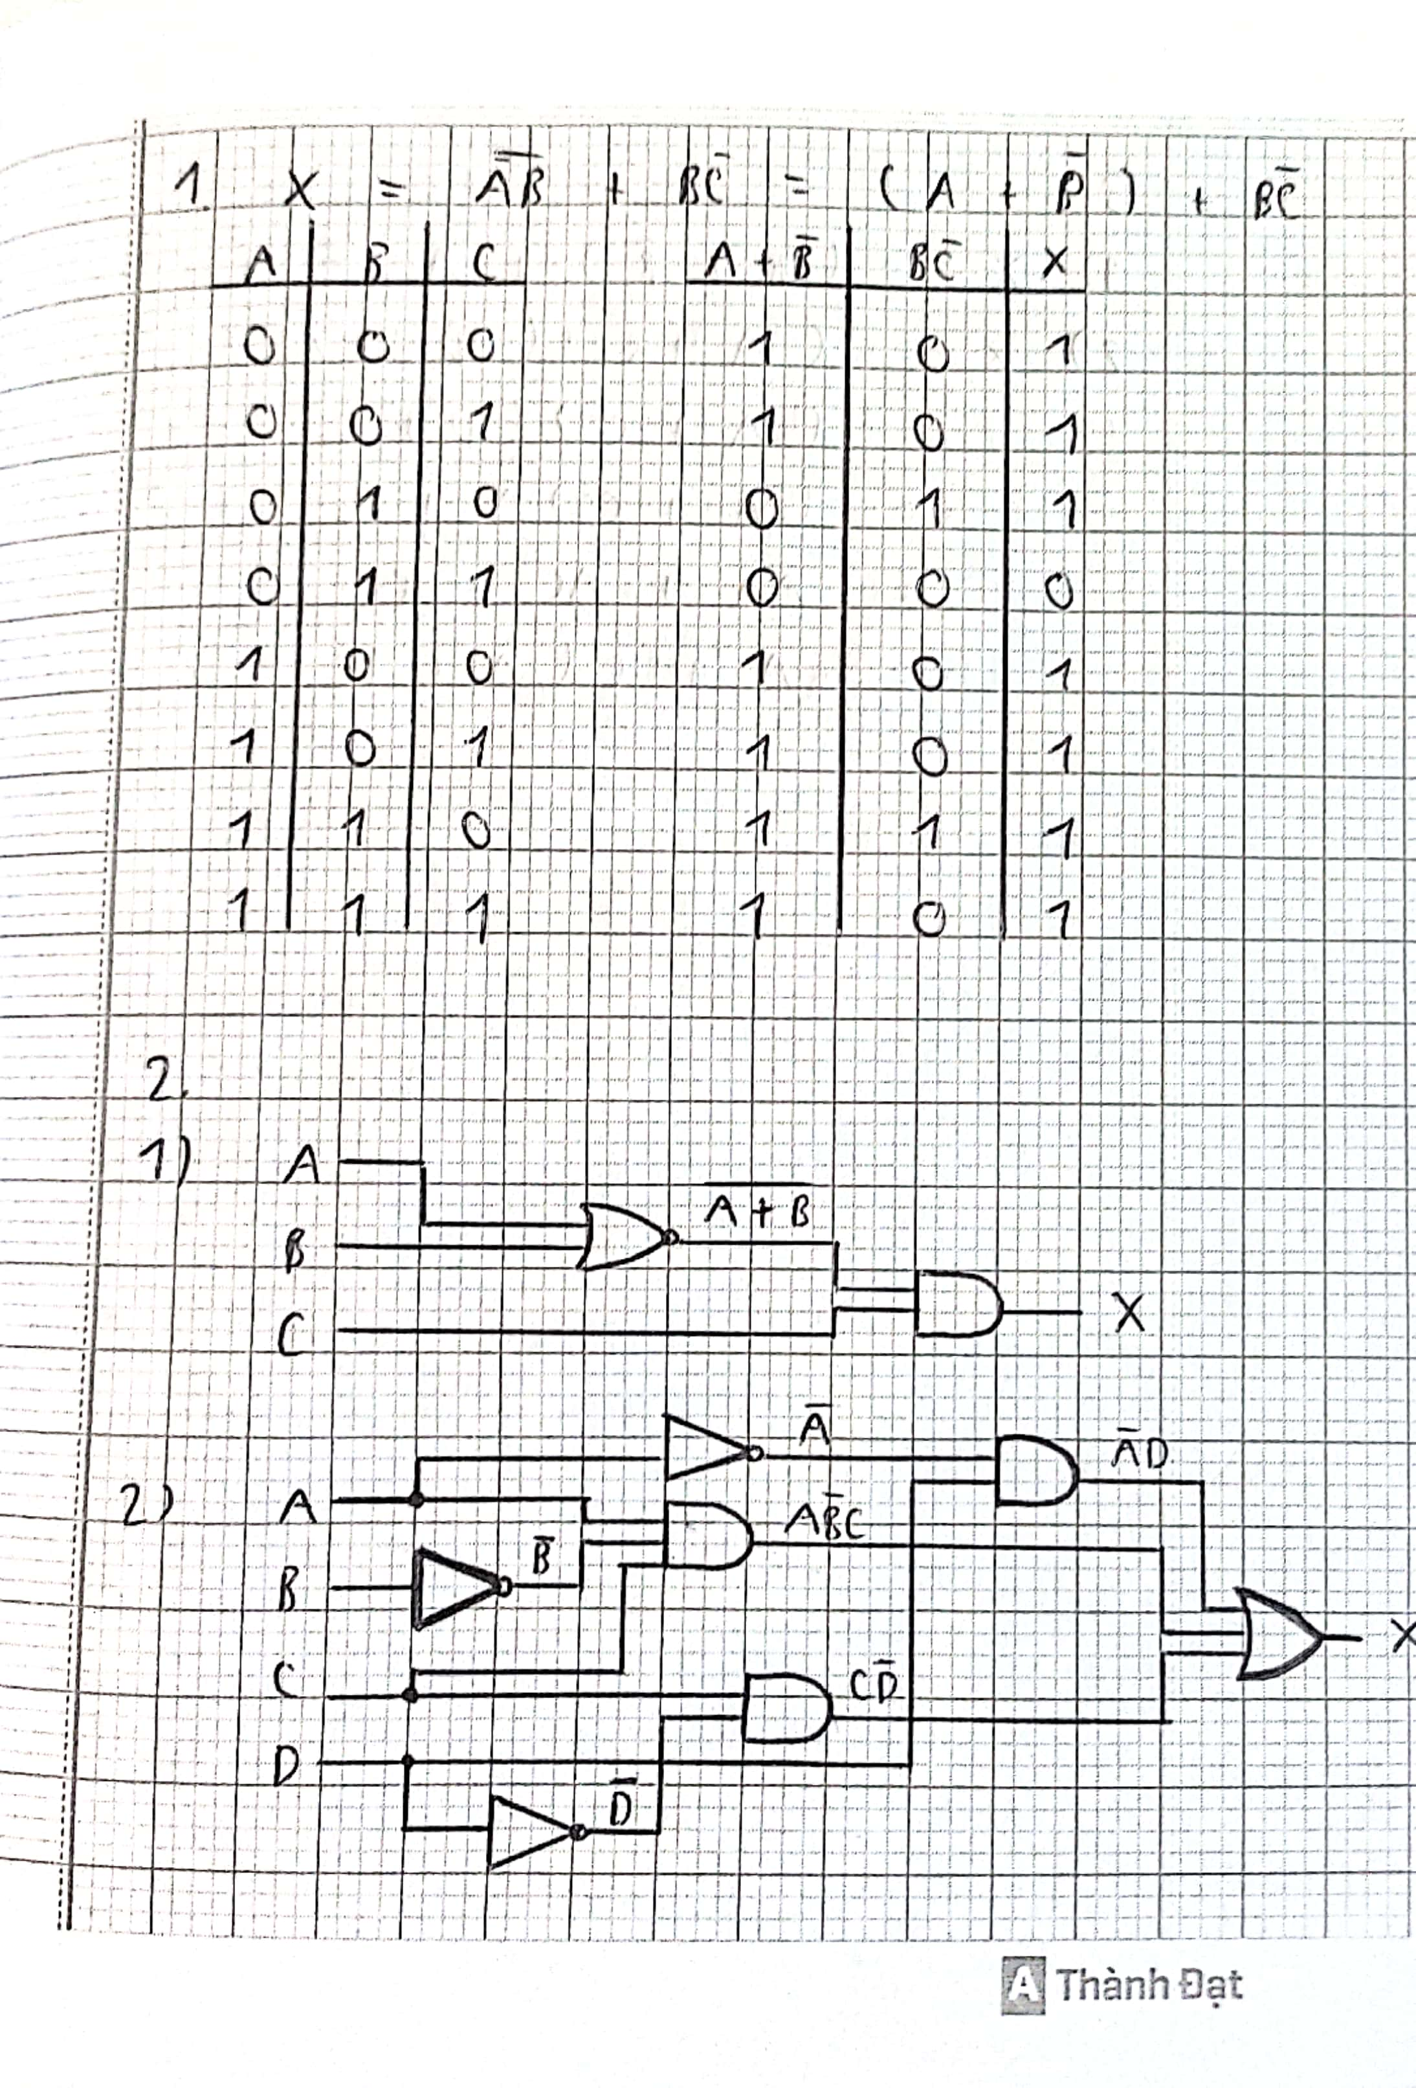

**Problem 3 solution:**

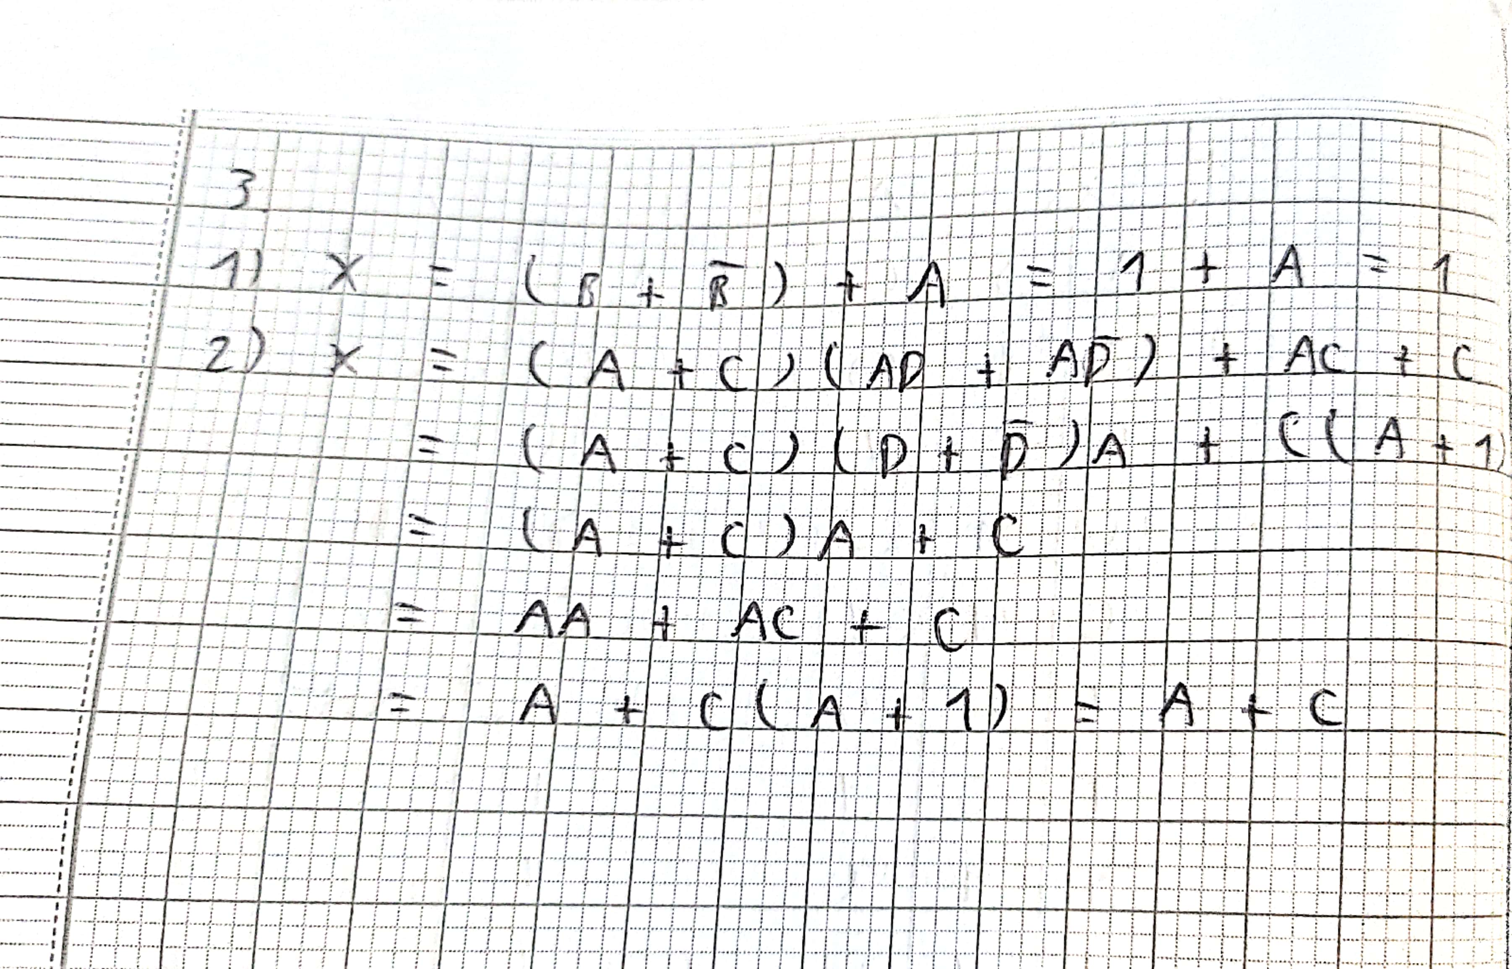

Pass Borderline Task 6

**Problem 1 solution:**

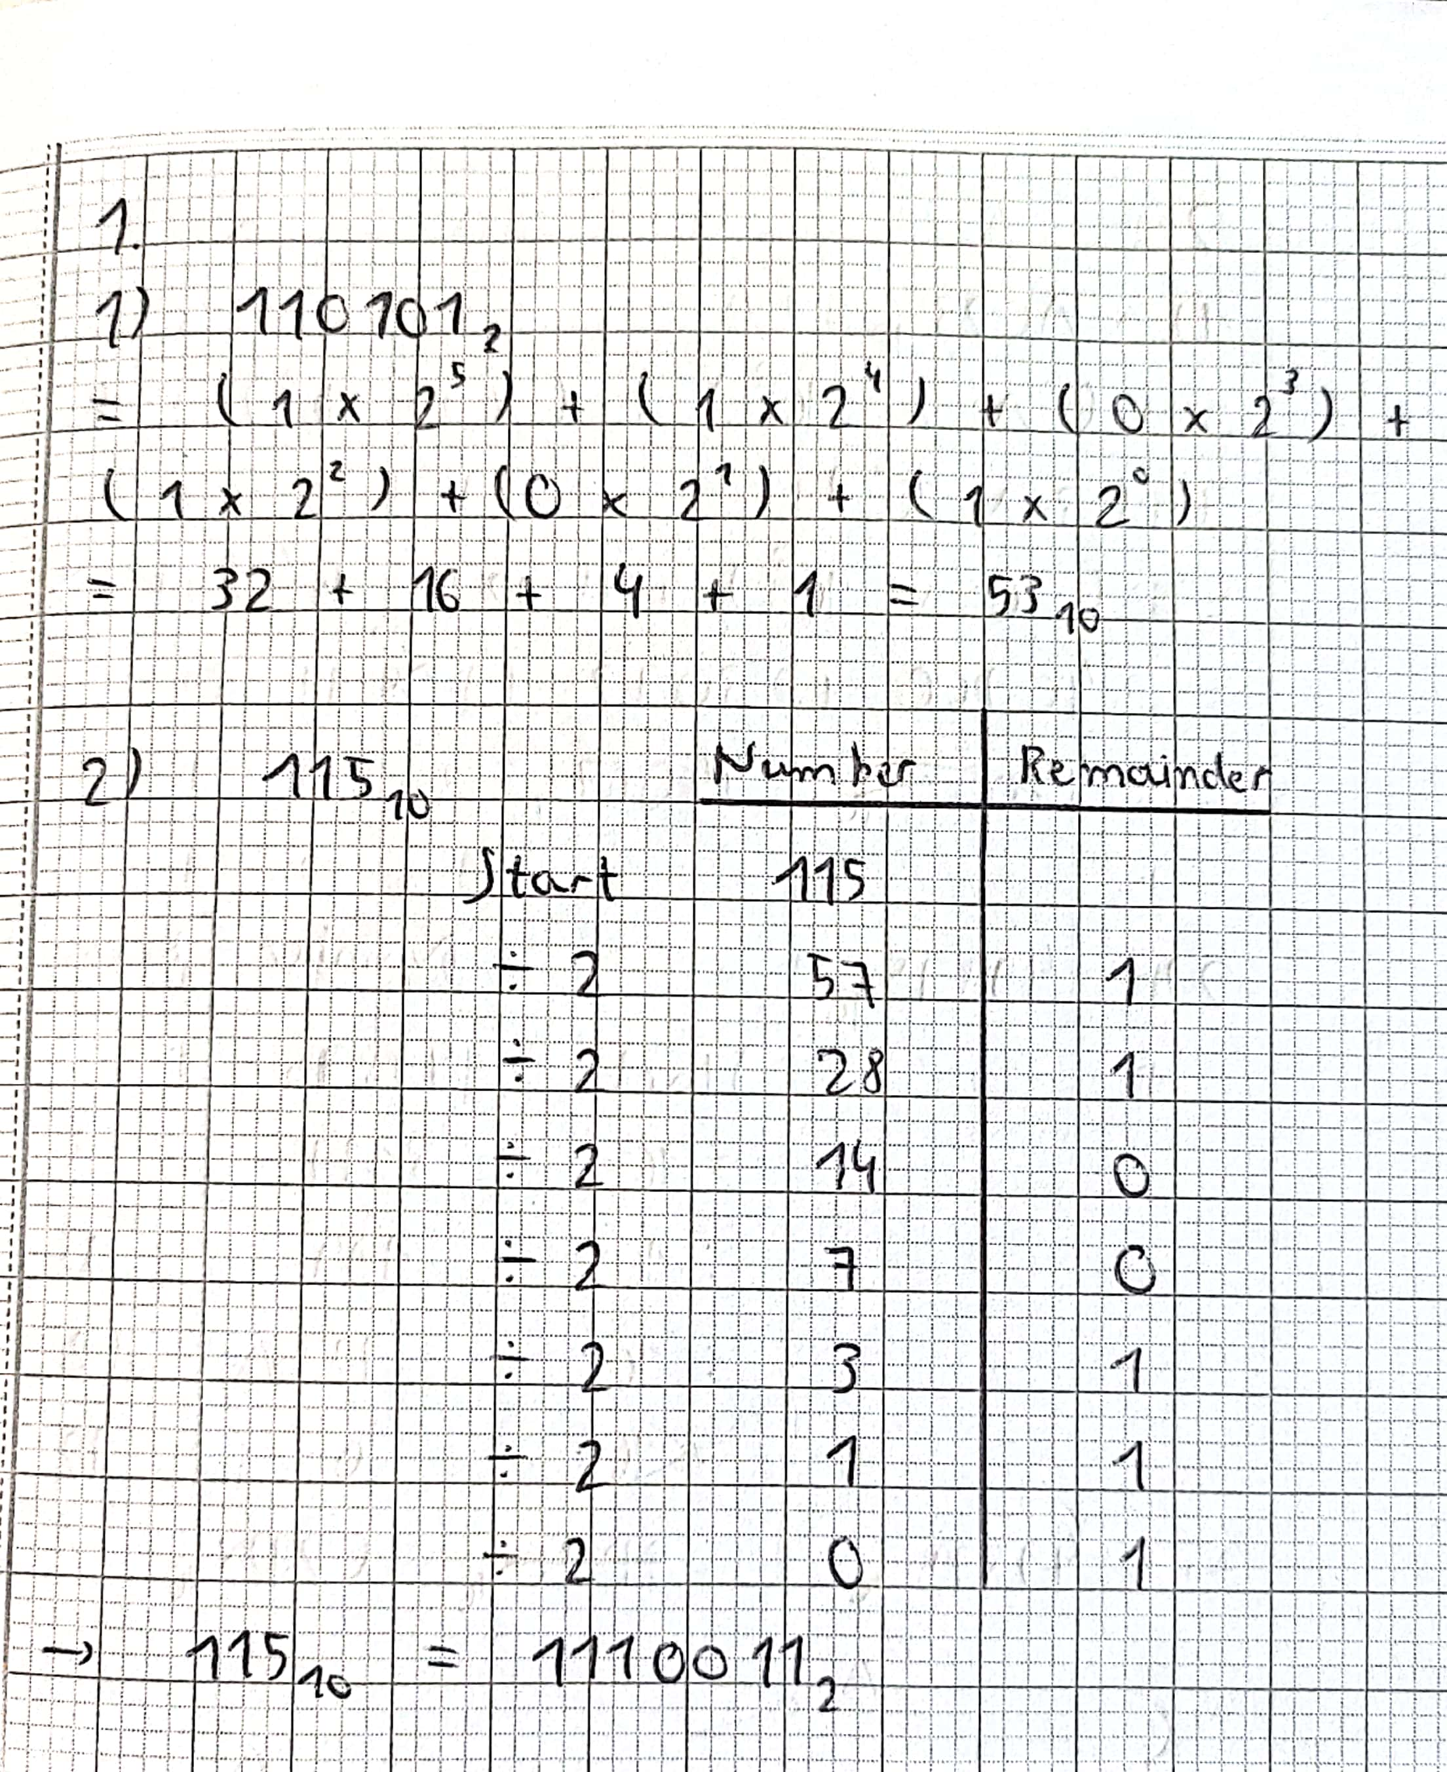

**Problem 2**

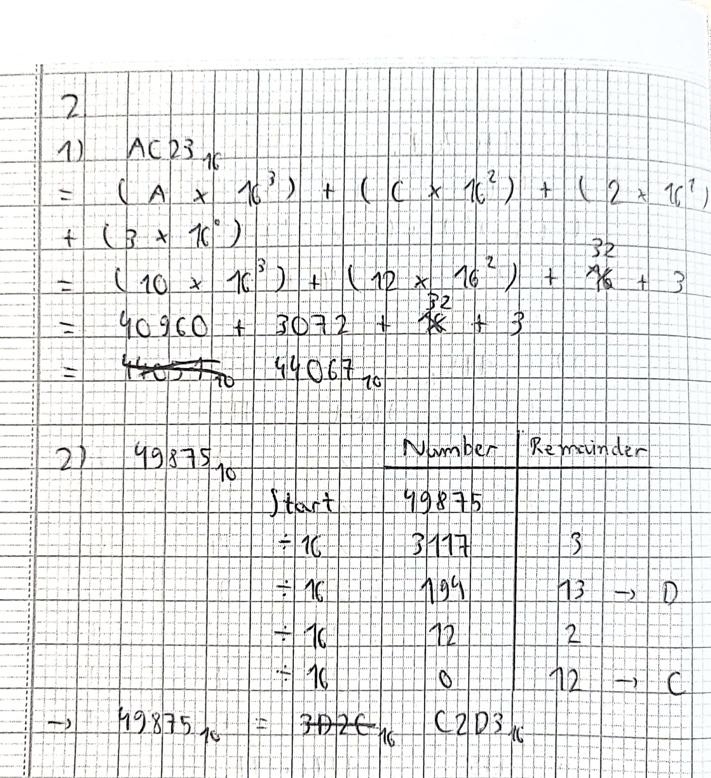

**Problem 3 solution:**

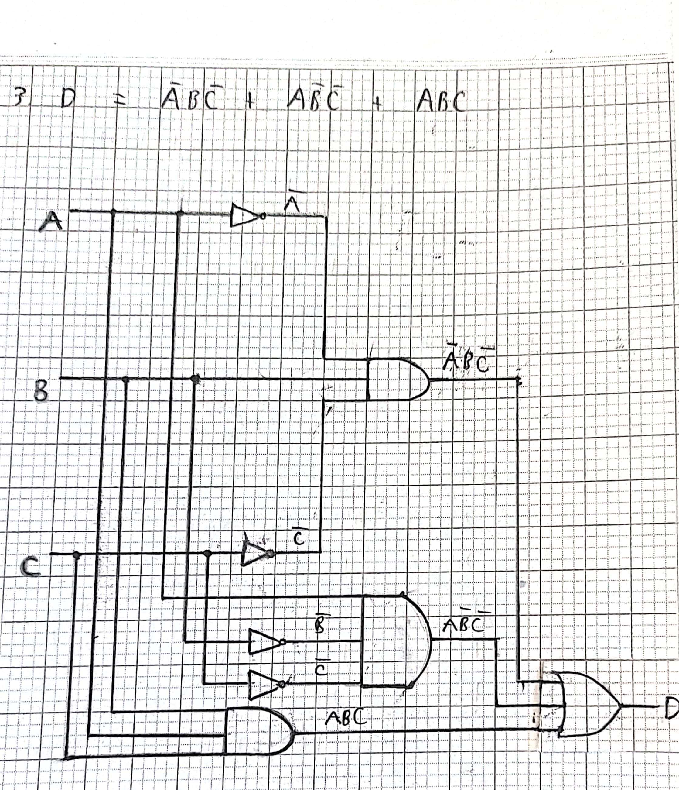

Pass Plus Task 1

Problem 1 solution:

% Creating 1st subplot

subplot(2,1,1);

t = 0:0.01:4;

% Plotting the amplitude

plot(t, abs((3 + 3.6i)*t - 3.0));

title('Amplitude and phase plot of complex number');

ylabel('Amplitude');

% Creating 2nd subplot

subplot(2,1,2);

t = 0:0.01:4;

% Plotting the phase

plot(t, rad2deg(angle((3 + 3.6i)*t - 3.0)));

xlabel('t');

ylabel('Phase (degree)')



Problem 2 solution:

function [] = PPTask1p2_f( N )

for i = 1:N

DivByThree = false;

DivBySeven = false;

if rem(i,3) == 0

DivByThree = true;

end

if rem(i,7) == 0

DivBySeven = true;

end

if (DivByThree && DivBySeven)

disp(num2str(i) + " is divisible by 3 and 7.")

elseif DivByThree

disp(num2str(i) + " is divisible by 3.")

elseif DivBySeven

disp(num2str(i) + " is divisible by 7.")

else

disp(num2str(i) + " is NOT divisible by 3 or 7.")

end

end

>> PPTask1p2_f

1 is NOT divisible by 3 or 7.

2 is NOT divisible by 3 or 7.

3 is divisible by 3.

4 is NOT divisible by 3 or 7.

5 is NOT divisible by 3 or 7.

6 is divisible by 3.

7 is divisible by 7.

8 is NOT divisible by 3 or 7.

9 is divisible by 3.

10 is NOT divisible by 3 or 7.

11 is NOT divisible by 3 or 7.

12 is divisible by 3.

13 is NOT divisible by 3 or 7.

14 is divisible by 7.

15 is divisible by 3.

16 is NOT divisible by 3 or 7.

17 is NOT divisible by 3 or 7.

18 is divisible by 3.

19 is NOT divisible by 3 or 7.

20 is NOT divisible by 3 or 7.

21 is divisible by 3 and 7.

22 is NOT divisible by 3 or 7.

23 is NOT divisible by 3 or 7.

24 is divisible by 3.

25 is NOT divisible by 3 or 7.

Pass Plus Task 2

**Problem 1 solution:** 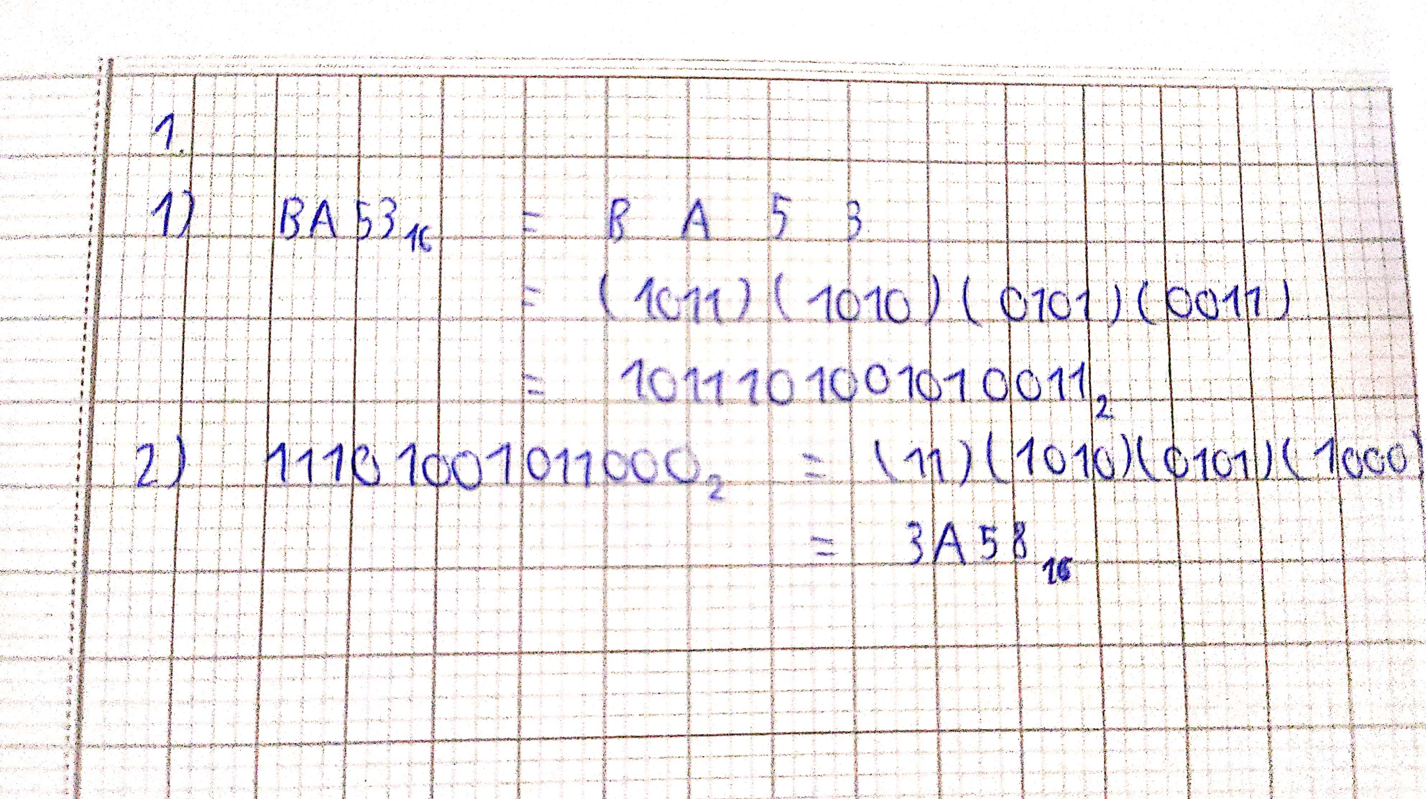

**Problem 2 solution:**

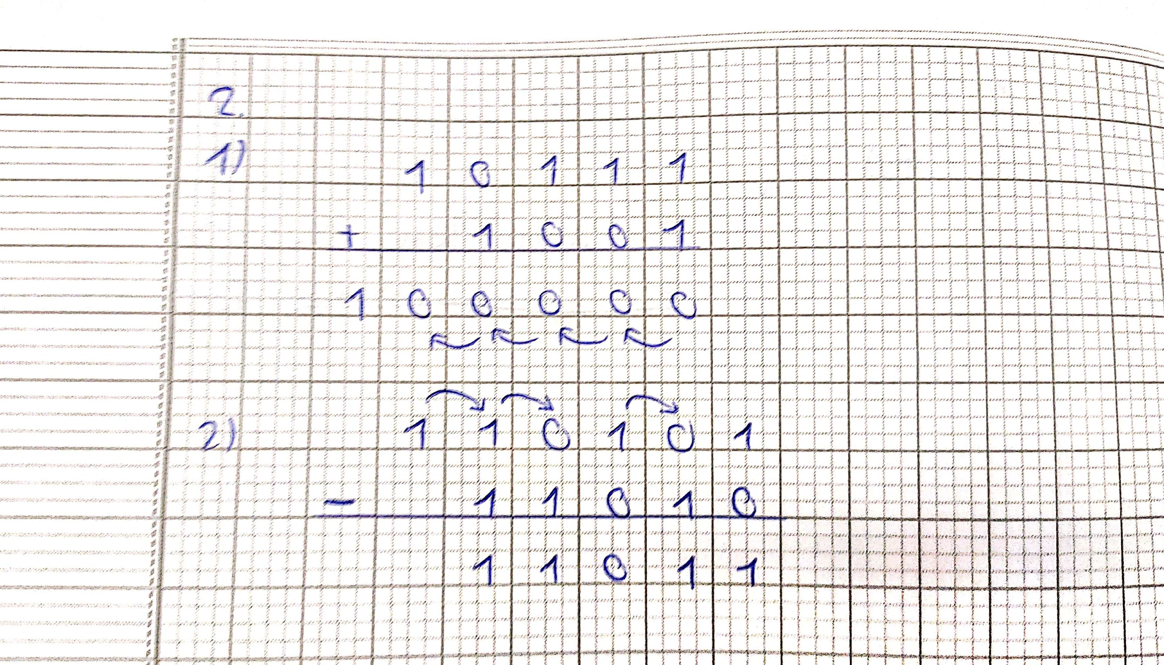

**Problem 3 solution:**

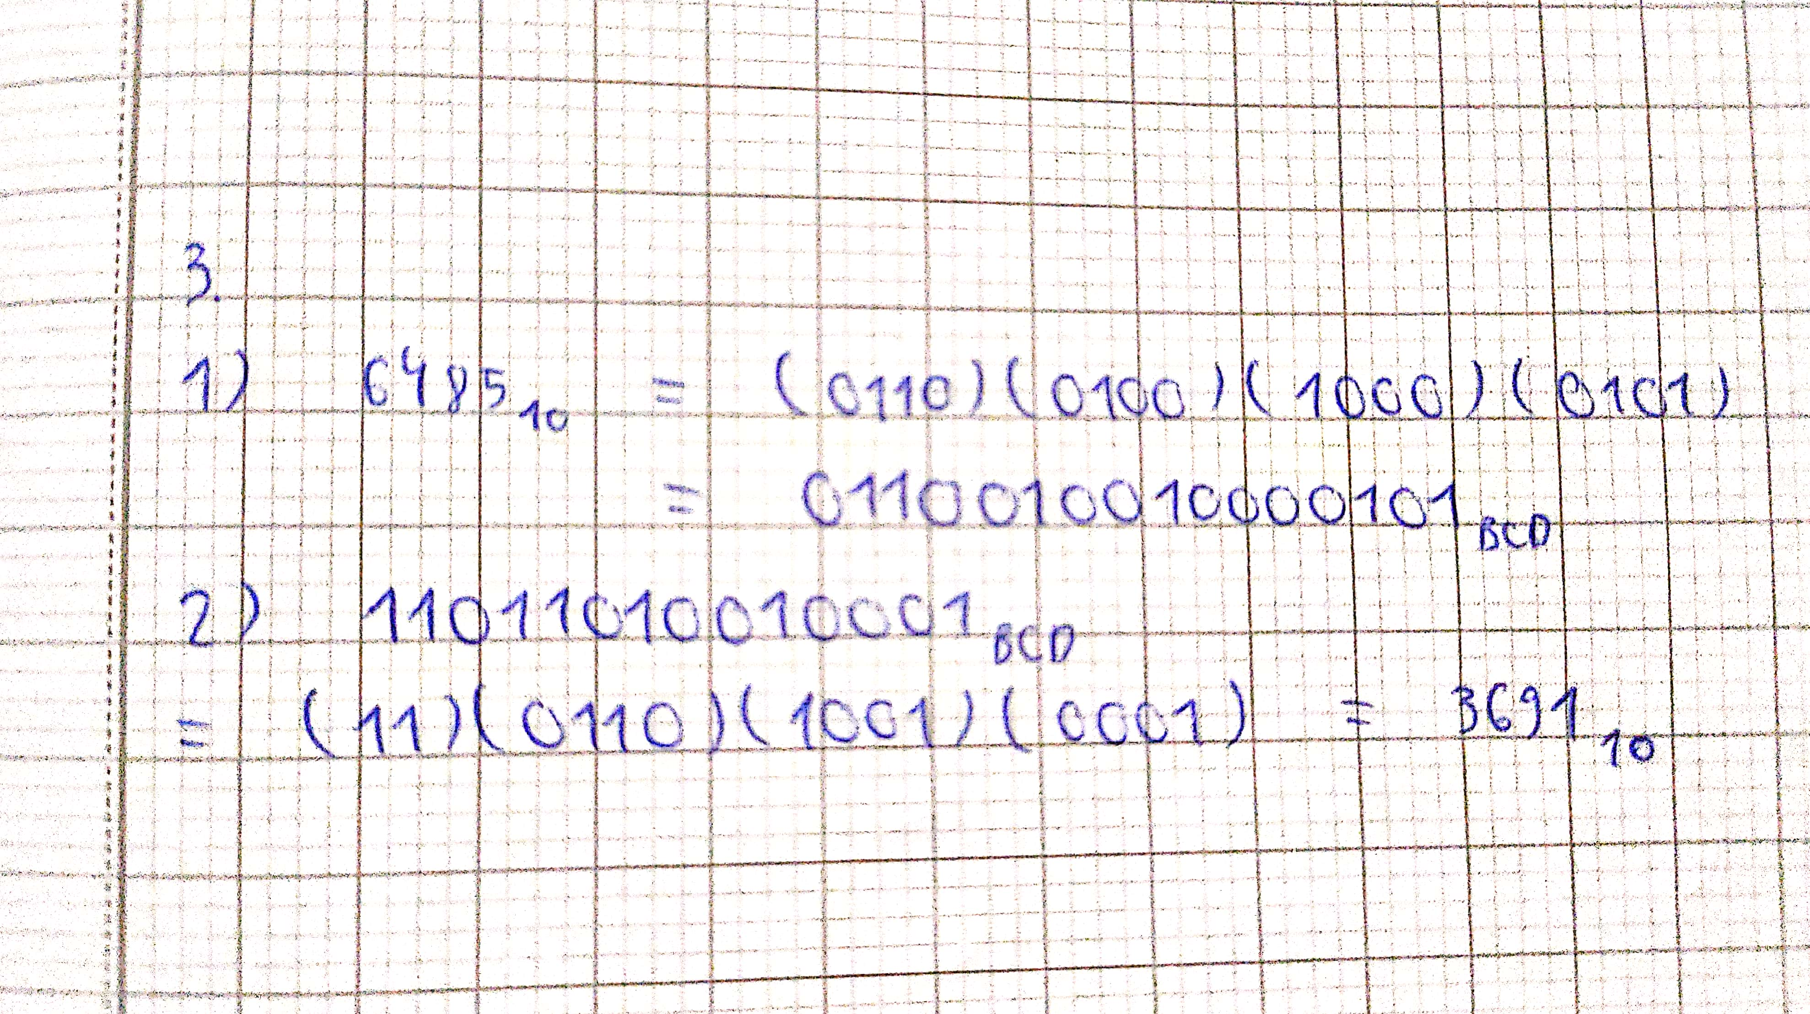

Credit Task 1

Problem 1 solution:

r = 1;

theta = 0:0.01:2*pi;

plot(r*cos(theta)+2,r*sin(theta)+2,'LineWidth',2.5,'Color','g');

hold on;

plot(r*cos(theta)+2,r*sin(theta)+4,'LineWidth',2.5,'Color','r');

hold on;

plot(r*cos(theta)+4,r*sin(theta)+2,'LineWidth',2.5,'Color','m');

hold on;

plot(r*cos(theta)+4,r*sin(theta)+4,'LineWidth',2.5,'Color','b');

hold on;

x1=2; x2=4; y1=2; y2=4;

x = [x1, x2, x2, x1, x1];

y = [y1, y1, y2, y2, y1];

plot(x, y,'LineWidth',1.5,'LineStyle','-.','Color','c');

hold off;

axis equal;

axis([0 6 0 6])



Problem 2 solution:

h = 1.8; % Initial Height

g = 9.8; % Gravitational acceleration

v = 4; % Initial Velocity

theta = 45; % Angle

t = linspace(0,1,1000); % Time t

xt = v*cos(theta*pi/180)*t;

yt = h+(v*sin(theta*pi/180)*t)-0.5*g*t.^2;

k = find(yt<0,1) % Find index at which distance becomes negative

fprintf('The ball hits the ground at distance of %.4f meters.\n',xt(k))

figure(1); % Plot new figure

plot(xt,yt,'LineWidth',1.5);

title('Ball trajectory');

xlabel('Distance (m)');

ylabel('Ball height (m)');

hold on;

plot([0 max(xt)],[0 0],'k--');

hold off



k =

960

Ball hits the ground at distance of 2.7152 meters

Credit Task 2

**Problem 1 solution:**

function smoothed = CTask2p1_f(x,width)

smoothed = zeros(size(x));

if rem(width,2) == 0

width = width + 1;

end

f1 = conv(x,ones(1,width),'same')/width;

smoothed(width - fix(width/2):length(x) - fix(width/2)) = f1(width - fix(width/2):length(x) - fix(width/2));

if width > 2*ceil(length(x)/2) + 1

width = 2*ceil(length(x)/2) + 1;

end

for i = 1:(width - fix(width/2)) - 1

smoothed(i) = mean([x(1:i-1),x(i:i+i-1)]);

end

for i = (width-fix(width/2))-1:-1:1

j = length(x)-i+1;

w = length(x)-j;

smoothed(j) = mean([x(j),x(j-w:j-1),x(j+1:length(x))]);

end

t = linspace(0,1,100);

noise = rand(1,length(t));

x = cos(2*pi*t) + 0.5*(rand(size(noise))-0.5);

y_5 = CTask2p1_f(x,5);

y_20 = CTask2p1_f(x,20);

figure(1)

plot(x,'o');hold on;

plot(y_5);

xlabel('index');

ylabel('Data value');

title('Smoothing filter');

legend('Original data','Smoothed with width = 5')

hold off;

figure(2)

plot(x,'o');hold on;

plot(y_20);

xlabel('index');

ylabel('Data value');

title('Smoothing filter');

legend('Original data','Smoothed with width = 20')

****hold off;



**Problem 2 solution:**

1. disp("-----------")

disp(" A B C D L");

disp("-----------")

for A = [0 1]

for B = [0 1]

for C = [0 1]

for D = [0 1]

L = or(xor(A, B), and(not(C), D));

fprintf(" %d %d %d %d %d\n", A, B, C, D, L);

end

end

end

end

-----------

A B C D L

-----------

0 0 0 0 0

0 0 0 1 1

0 0 1 0 0

0 0 1 1 0

0 1 0 0 1

0 1 0 1 1

0 1 1 0 1

0 1 1 1 1

1 0 0 0 1

1 0 0 1 1

1 0 1 0 1

1 0 1 1 1

1 1 0 0 0

1 1 0 1 1

1 1 1 0 0

1 1 1 1 0

1. **Question 1 PBT6**

>> a = bi2de([1 1 0 1 0 1],'left-msb')

a =

53

>> b = de2bi(115,'left-msb')

b =

1 1 1 0 0 1 1

**Question 2 PBT6**

>> c = hex2dec('AC23')

c =

44067

>> d = dec2hex(49875)

d =

'C2D3'

Distinction Task 1

function distance = DTask1_f(v, theta)

h = 1.8;

g = 9.8;

t = linspace(0,10,10001);

x = v*cos(theta*pi/180)*t;

y = h+v*sin(theta*pi/180)*t-.5*g*t.^2;

neg = find(y<0);

if isempty(neg)

fprintf('The ball does not hit the ground in 10 seconds.');

distance = NaN;

else

distance = x(neg(1));

end

clc; clear all;

v = input('Enter velocity: ')

theta = 0:1:60;

distance = zeros(1,61);

for i = 1:61

distance(i)=DTask1_f(v,theta(i));

end

figure

plot(theta,distance,'LineWidth',1.2)

xlabel('Initial angle (deg)')

ylabel('Distance thrown (m)')

title('Distance of ball thrown as a function of release angle')

legend(['v = ' num2str(v),'m/s'])

Enter velocity: 4

v =

4



Enter velocity: 60

v =

60

The ball does not hit the ground in 10 seconds.

The ball does not hit the ground in 10 seconds.

The ball does not hit the ground in 10 seconds.

The ball does not hit the ground in 10 seconds.

The ball does not hit the ground in 10 seconds.

The ball does not hit the ground in 10 seconds.



Distinction Task 2

1. Truth table for full subtractor

As there are three inputs to full subtractor X, Y, Bin, there will be 23 = 8 combinations.

|  |  |  |  |  |
| --- | --- | --- | --- | --- |
| **Input** | | | **Output** | |
| *X* | *Y* | *Bin* | *D* | *Bout* |
| 0 | 0 | 0 | 0 | 0 |
| 0 | 0 | 1 | 1 | 1 |
| 0 | 1 | 0 | 1 | 1 |
| 0 | 1 | 1 | 0 | 1 |
| 1 | 0 | 0 | 1 | 0 |
| 1 | 0 | 1 | 0 | 0 |
| 1 | 1 | 0 | 0 | 0 |
| 1 | 1 | 1 | 1 | 1 |

*Kmap for D:*

|  |  |  |  |  |
| --- | --- | --- | --- | --- |
| Y - Bin  X | 00 | 01 | 11 | 10 |
| 0 | 0 | 1 | 0 | 1 |
| 1 | 1 | 0 | 1 | 0 |

*Simplifying D:*

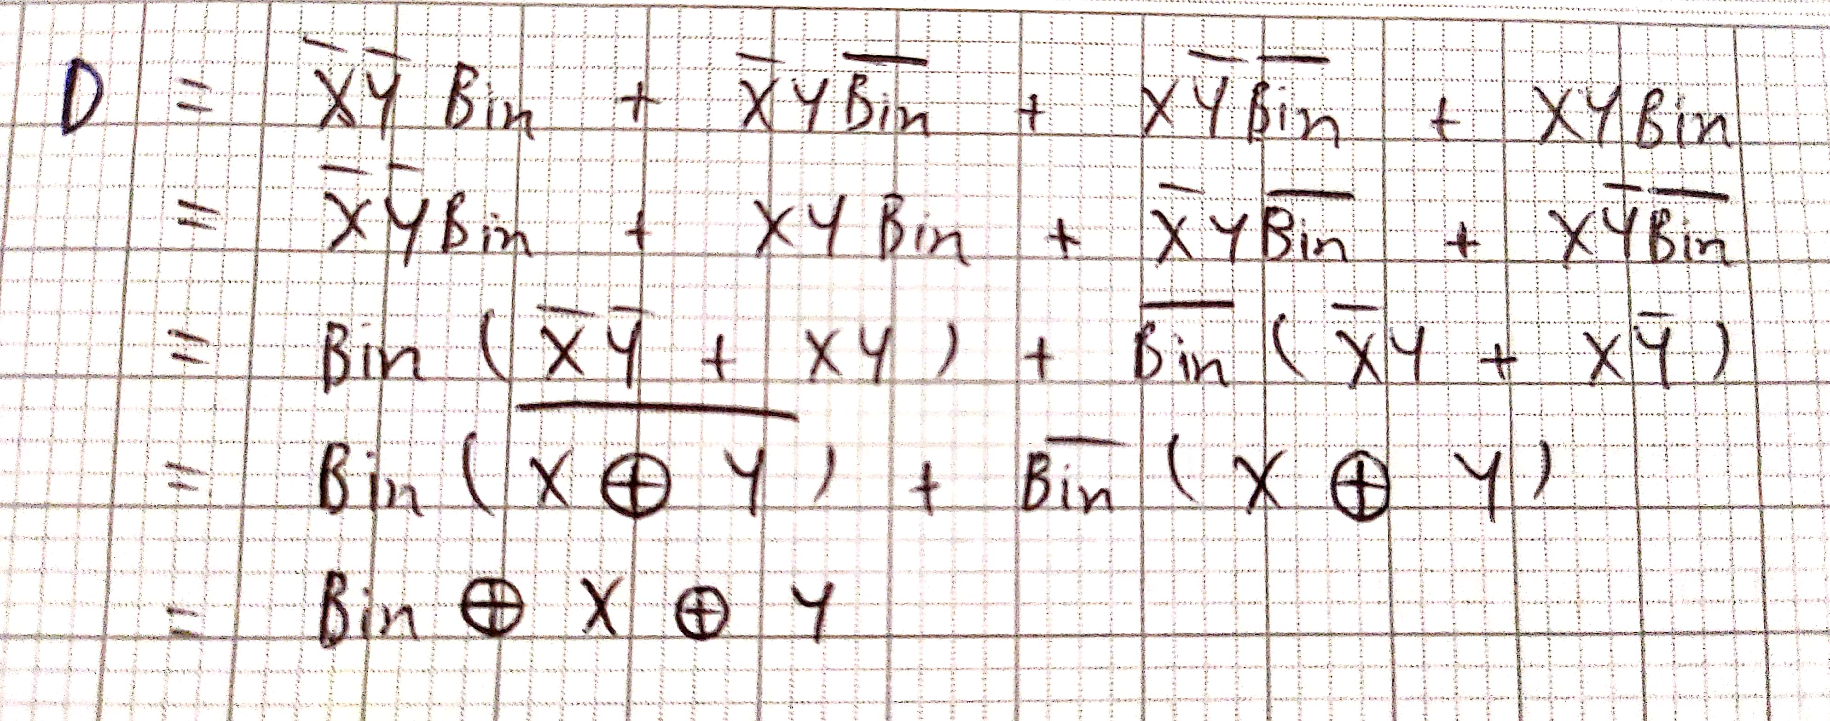

*Kmap for* *Bout:*

|  |  |  |  |  |
| --- | --- | --- | --- | --- |
| Y - Bin  X | 00 | 01 | 11 | 10 |
| 0 | 0 | 1 | 1 | 1 |
| 1 | 0 | 0 | 1 | 0 |

*Simplifying Bout:*

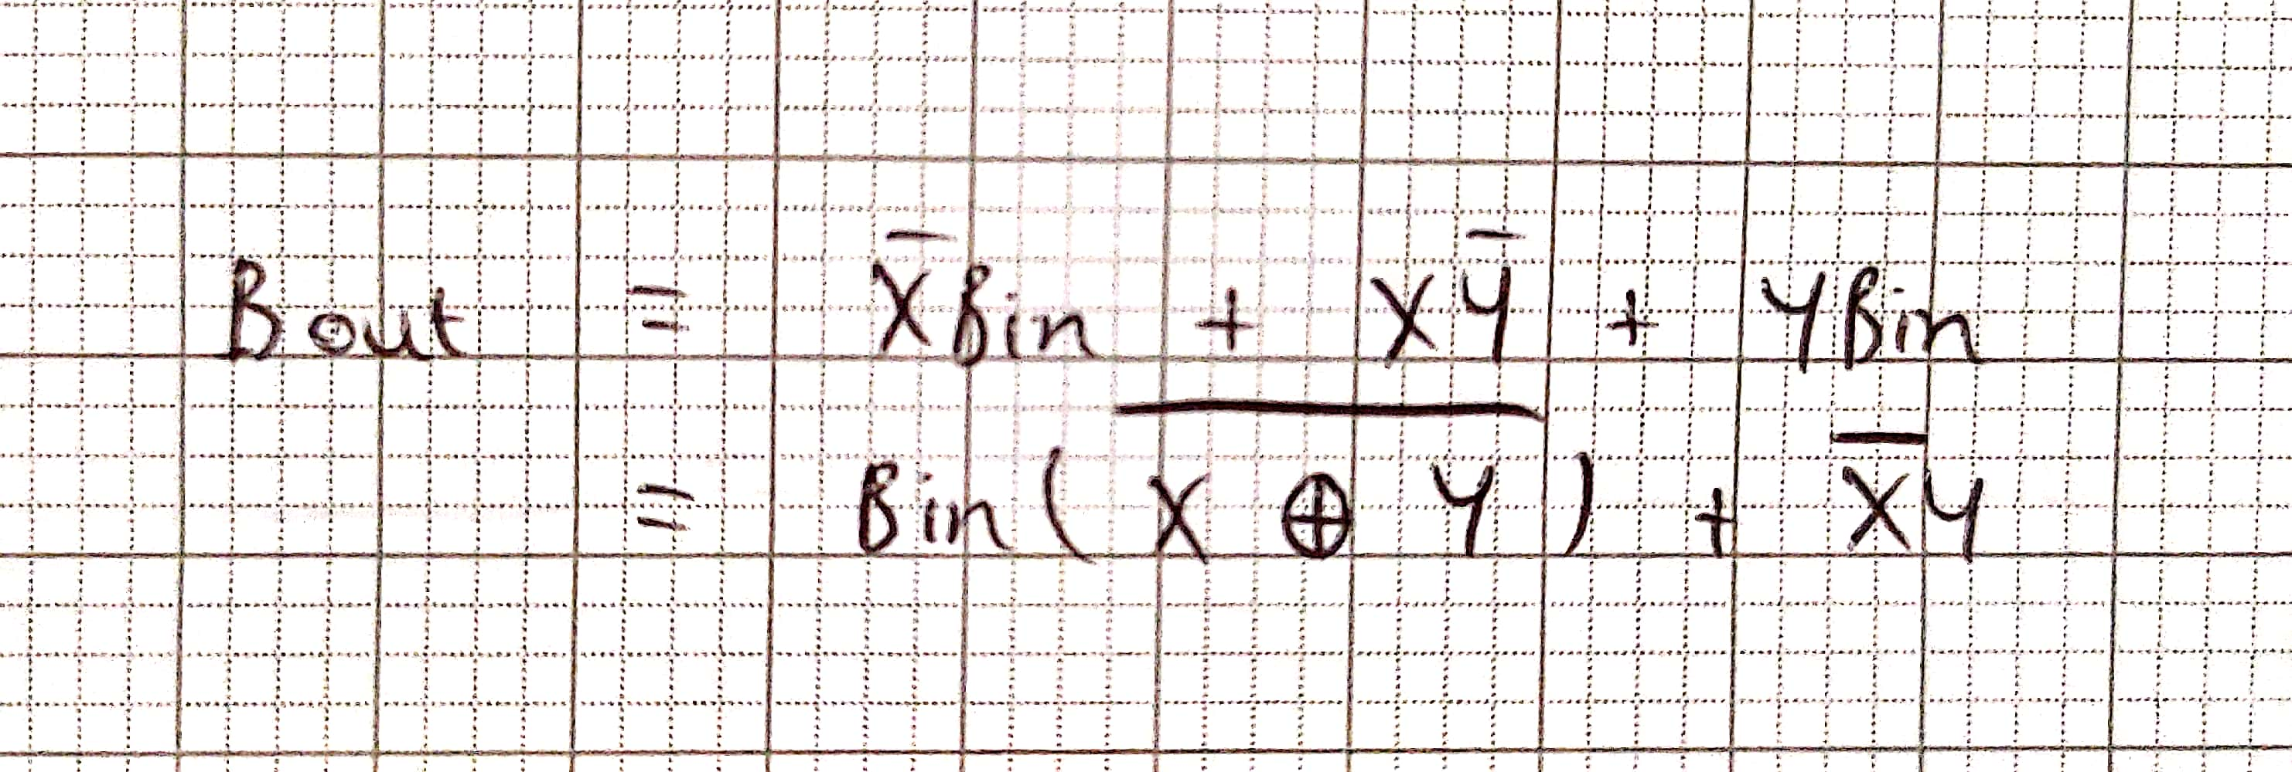

1. Circuit diagram:

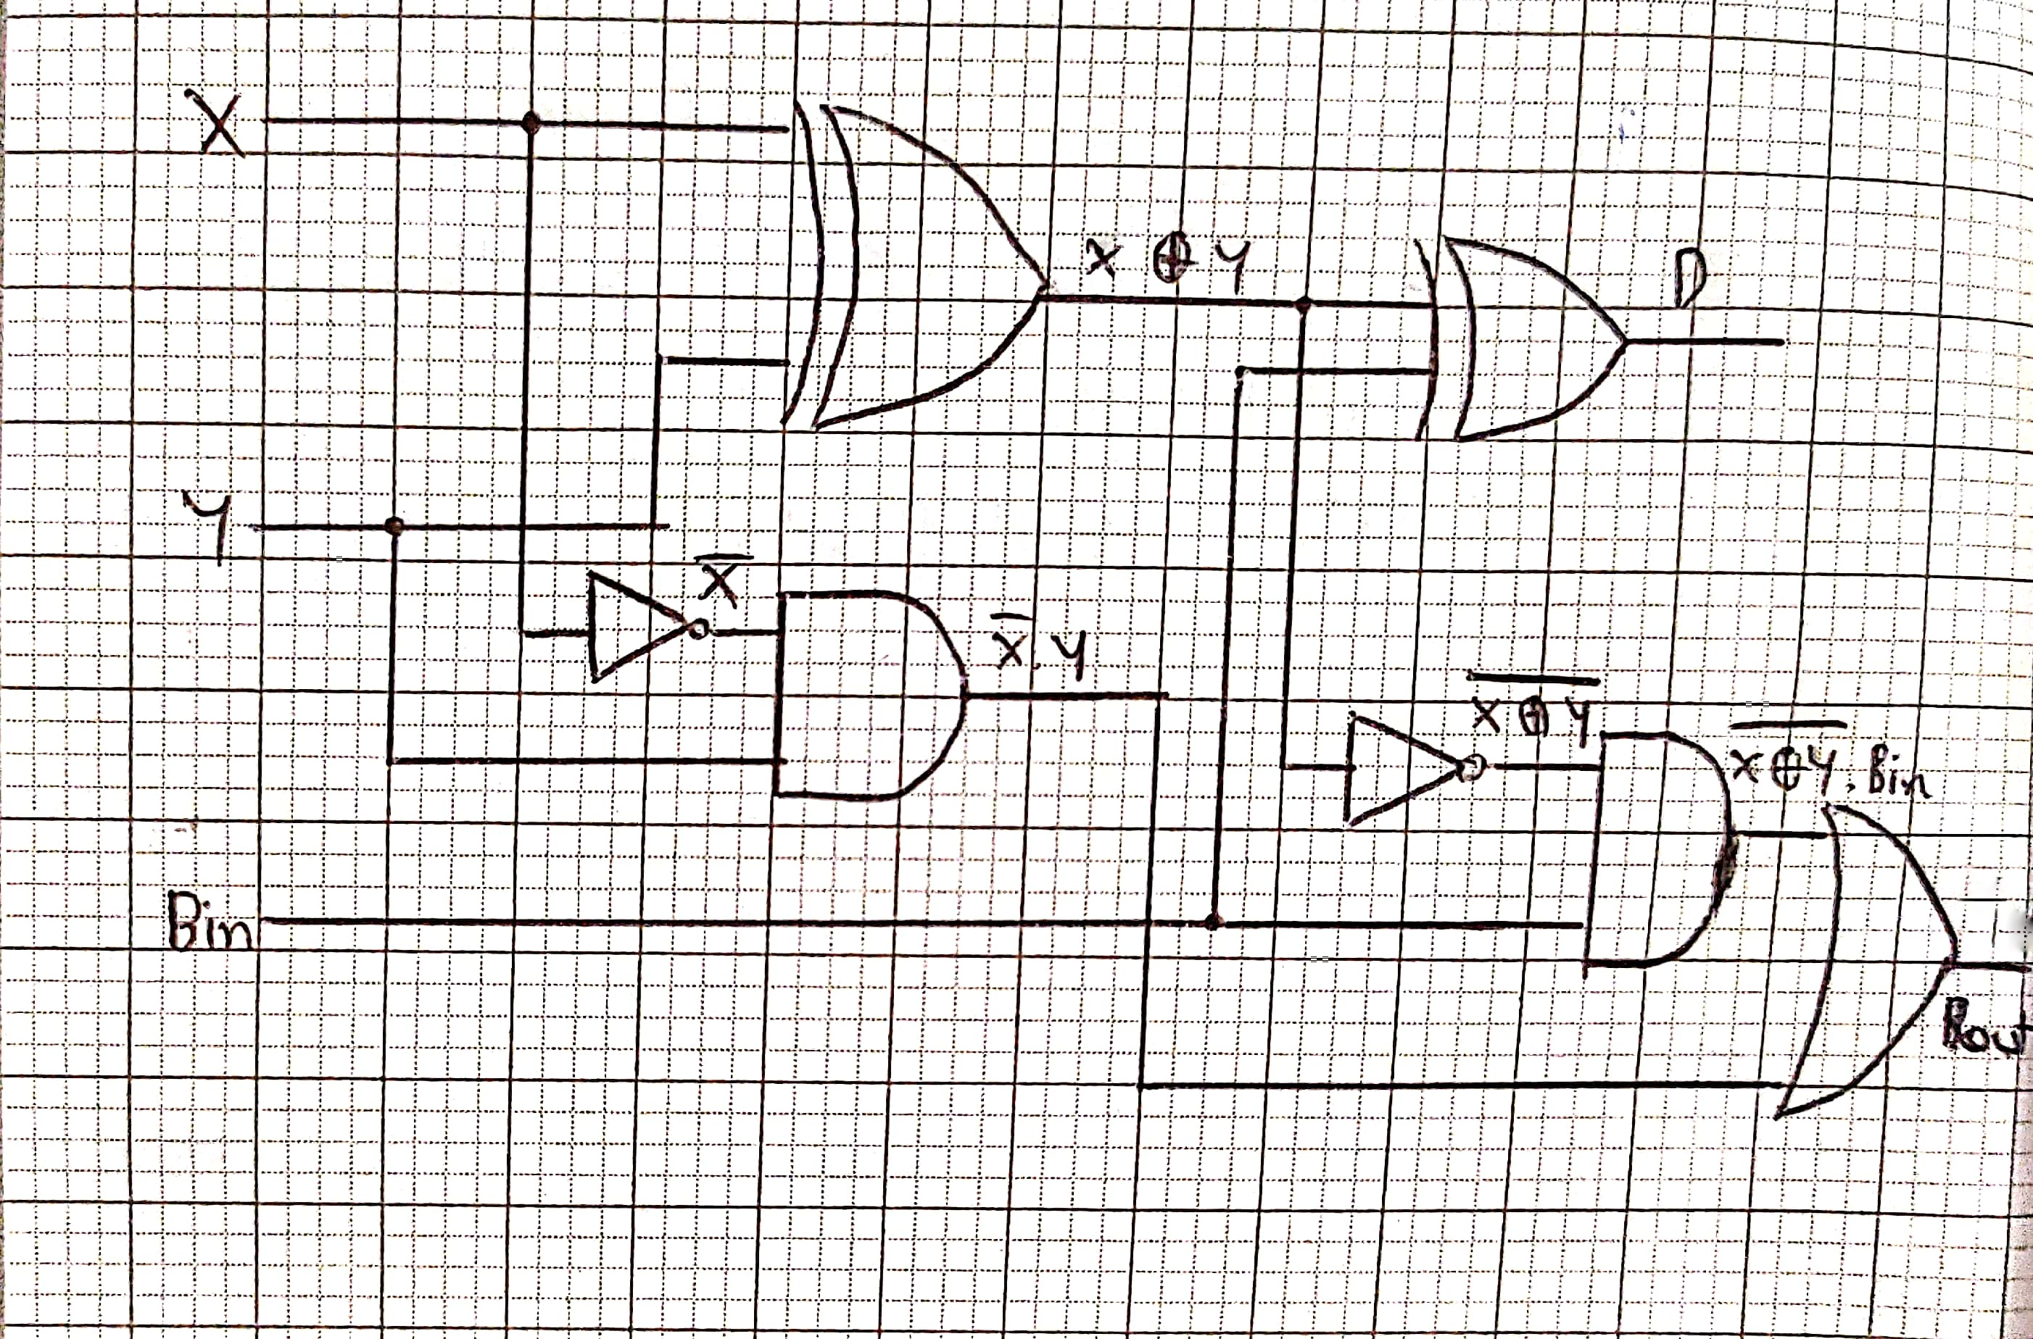

High Distinction Task 1

close all; clear all; clc;

% Show ground level and ball initial level

rectangle('Position', [0 1.5 0.5 0], 'EdgeColor', 'c')

rectangle('Position', [0 0 10 0], 'EdgeColor', 'k')

% Score Board

score = 0;

text(3, 2, 'Score: ', 'Color', 'black', 'FontSize', 12);

init_txt = text(3.5, 2, num2str(score), 'Color', 'black', 'FontSize', 12);

% Command line inputs

while 1

% Plot the ball

init_ball = plot_ball(0, 1.5);

% Hit Board

[A, B, board] = hit_board(rand_num());

user_input = input('To exit the game, enter x (ok goodbye). \n To play the game (yay, you are playing), enter a shooting angle beteen -90 and 90 degree: ', 's');

if user_input == 'x' % Check user input == x

disp('Game exit');

close all;

clear all;

break

else

new_num = str2num(user_input);

if (isreal(new_num) && isscalar(new_num)) % Check user input is valid number or not

if ((str2num(user_input) >= -90) && (str2num(user_input) <= 90)) % Check user input is between -90 & 90

disp('There goes the ball');

delete(init_ball)

hitted_x = shoot_curve(new_num);

if (hitted_x >= A && hitted_x <= B)

% Adding score

score = score + 1;

score_board(init_txt, score);

end

else

disp('Invalid angle bro');

delete(init_ball)

end

elseif (imag(new_num) ~= 0)

disp('Enter a real number (-90~99) rather than any complex number, lol!');

delete(init_ball)

elseif ~(isscalar(new_num))

disp('Enter a real number (-90~99) rather than any string, lmao!');

delete(init_ball)

end

end

pause(0.5)

delete(board)

end

% Hit Board function

function [x1, x2, board] = hit_board(b)

if b == 1

clr = 'r';

elseif b == 2

clr = 'g';

elseif b == 3

clr = 'y';

else

clr = 'b';

end

temp_rn = randperm(10,1); % To get more random position

x1 = (b-1) + (temp_rn./10);

x2 = x1 + 0.5;

y1 = 0;

% plot(x, y, clr, 'LineWidth', 5);

board = rectangle('Position',[x1, y1, 0.5, 0.05], 'FaceColor', clr, 'EdgeColor', 'k', 'LineWidth', 1);

axis([0, 4, -1, 2.5]);

end

% Score Board function

function score_board(txt, score)

set(txt, 'String', num2str(score))

end

% Random number function

function rn = rand_num()

rn = randperm(3,1);

end

% Plot the ball function

function pb = plot_ball(x,y)

% plot(x, y, 'ro', 'markerfacecolor', 'r','MarkerSize', 15);

pb = rectangle('Position', [x y 0.1 0.1], 'Curvature', [1 1], 'FaceColor', 'r', 'EdgeColor', 'k', 'LineWidth',1);

axis([0, 4, -1, 2.5]);

end

% Shoot the curve function

function hit_x = shoot_curve(ang)

% constants and initial values

g = 9.8; % acceleration of gravity

v0 = 4; % initial velocity

th = ang.*pi./180; % radians, launch angle

y0 = 1.8; % initial height (m)

x0 = 0; % initial position (m)

val=0;

[vx0,vy0] = pol2cart(th,v0); % transforms corresponding elements of the polar coordinate arrays theta and rho to two-dimensional Cartesian

t = linspace(0,max(roots([-g./2, vy0, y0])),100); % y = linspace(x1,x2,n) generates n points. The spacing between the points is (x2-x1)/(n-1).

x = x0 + vx0.*t;

y = y0 + vy0.*t - 0.5 .* g .* t .^2;

axis equal

while 1

val=val+1;

if val == 100

break;

end

% hold on; % To hold the graph

% plot(x(val), y(val), 'c.', 'markerfacecolor', 'c','MarkerSize', 5);

axis([0, 4, -1, 2.5]);

my = plot_ball(x(val), y(val));

pause(0.005);

if val == 99

pause(0.5)

delete(my)

else

delete(my)

end

end

axis([0, 4, -1, 2.5]);

hit_x = x(100);

end

To exit the game, enter x (ok goodbye).

To play the game (yay, you are playing), enter a shooting angle beteen -90 and 90 degree: 15

There goes the ball



To exit the game, enter x (ok goodbye).

To play the game (yay, you are playing), enter a shooting angle beteen -90 and 90 degree: 5i

Enter a real number (-90~99) rather than any complex number, lol!

To exit the game, enter x (ok goodbye).

To play the game (yay, you are playing), enter a shooting angle beteen -90 and 90 degree: bruh

Enter a real number (-90~99) rather than any string, lmao!

To exit the game, enter x (ok goodbye).

To play the game (yay, you are playing), enter a shooting angle beteen -90 and 90 degree: 69420

Invalid angle bro

High Distinction Task 2

|  |  |  |  |  |  |  |  |  |  |  |  |
| --- | --- | --- | --- | --- | --- | --- | --- | --- | --- | --- | --- |
| **Number** | **Inputs** | | | | **Outputs** | | | | | | |
| **A3** | **A2** | **A1** | **A0** | **a** | **b** | **c** | **d** | **e** | **f** | **g** |
| **0** | 0 | 0 | 0 | 0 | 1 | 1 | 1 | 1 | 1 | 1 | 0 |
| **1** | 0 | 0 | 0 | 1 | 0 | 1 | 1 | 0 | 0 | 0 | 0 |
| **2** | 0 | 0 | 1 | 0 | 1 | 1 | 0 | 1 | 1 | 0 | 1 |
| **3** | 0 | 0 | 1 | 1 | 1 | 1 | 1 | 1 | 0 | 0 | 1 |
| **4** | 0 | 1 | 0 | 0 | 0 | 1 | 1 | 0 | 0 | 1 | 1 |
| **5** | 0 | 1 | 0 | 1 | 1 | 0 | 1 | 1 | 0 | 1 | 1 |
| **6** | 0 | 1 | 1 | 0 | 1 | 0 | 1 | 1 | 1 | 1 | 1 |
| **7** | 0 | 1 | 1 | 1 | 1 | 1 | 1 | 0 | 0 | 0 | 0 |
| **8** | 1 | 0 | 0 | 0 | 1 | 1 | 1 | 1 | 1 | 1 | 1 |
| **9** | 1 | 0 | 0 | 1 | 1 | 1 | 1 | 1 | 0 | 1 | 1 |
| **10 - 15** | *Don’t care cases* | | | | X | | | | | | |

* + 1. Karnaugh Map:

a)

|  |  |  |  |  |
| --- | --- | --- | --- | --- |
| A1A0  A2A3 | 00 | 01 | 11 | 10 |
| 00 | 1 | 0 | 1 | 1 |
| 01 | 0 | 1 | 1 | 1 |
| 11 | X | X | X | X |
| 10 | 1 | 1 | X | X |

b)

|  |  |  |  |  |
| --- | --- | --- | --- | --- |
| A1A0  A2A3 | 00 | 01 | 11 | 10 |
| 00 | 1 | 1 | 1 | 1 |
| 01 | 1 | 0 | 1 | 0 |
| 11 | X | X | X | X |
| 10 | 1 | 1 | X | X |

c)

|  |  |  |  |  |
| --- | --- | --- | --- | --- |
| A1A0  A2A3 | 00 | 01 | 11 | 10 |
| 00 | 1 | 1 | 1 | 0 |
| 01 | 1 | 1 | 1 | 1 |
| 11 | X | X | X | X |
| 10 | 1 | 1 | X | X |

d)

|  |  |  |  |  |
| --- | --- | --- | --- | --- |
| A1A0  A2A3 | 00 | 01 | 11 | 10 |
| 00 | 1 | 0 | 1 | 1 |
| 01 | 0 | 1 | 0 | 1 |
| 11 | X | X | X | X |
| 10 | 1 | 1 | X | X |

e)

|  |  |  |  |  |
| --- | --- | --- | --- | --- |
| A1A0  A2A3 | 00 | 01 | 11 | 10 |
| 00 | 1 | 0 | 0 | 1 |
| 01 | 0 | 0 | 0 | 1 |
| 11 | X | X | X | X |
| 10 | 1 | 0 | X | X |

f)

|  |  |  |  |  |
| --- | --- | --- | --- | --- |
| A1A0  A2A3 | 00 | 01 | 11 | 10 |
| 00 | 1 | 0 | 0 | 0 |
| 01 | 1 | 1 | 0 | 1 |
| 11 | X | X | X | X |
| 10 | 1 | 1 | X | X |

g)

|  |  |  |  |  |
| --- | --- | --- | --- | --- |
| A1A0  A2A3 | 00 | 01 | 11 | 10 |
| 00 | 0 | 0 | 1 | 1 |
| 01 | 1 | 1 | 0 | 1 |
| 11 | X | X | X | X |
| 10 | 1 | 1 | X | X |

3)

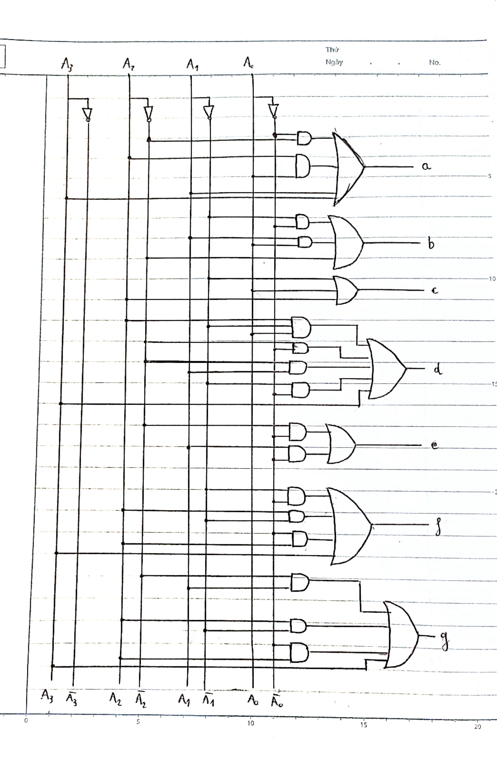

4) The program is:

Clear;

flag = 0;

%input process

while flag ==0

i_c=0;

s_c=0;

d_c=0;

c_c=0;

n_c=0;

disp('To exit, enter "x"');

number = input('Enter integer from 0 to 9: ','s');

if isempty(number)==1

disp("No input found!");

elseif strlength(number)==1

if number == 'x'

return

else

number=str2double(number);

if (number - 0 >=0)&&(number - 9 <=0)

flag=1;

end

end

else

for i=1:strlength(number)

if number(i)=='i'

i_c=i_c+1;

if (i+1<=length(number))&&((number(i+1) ~='+')||(number(i+1)~= '-'))

c_c=c_c+1;

end

elseif (number(i)=='+')||(number(i)=='-')

s_c=s_c+1;

if (i+1<=length(number))&&(((number(i+1) - '0'<0)||(number(i+1) - '9' >0)))&&(number(i+1)~='i')

c_c=c_c+1;

end

elseif number(i)=='.'

d_c=d_c+1;

if i+1<=length(number)

if ((number(i+1) - '0' <0)||(number(i+1) - '9' >0))

c_c=c_c+1;

end

end

elseif (number(i) - '0' <0)||(number(i) - '9' >0)

c_c=c_c+1;

else

n_c=n_c+1;

end

end

if c_c >0

disp('No string please');

elseif i_c==1

disp('No complex number please');

elseif d_c==1

disp('No decimal number please');

elseif (s_c>0)&&(i_c~=1)

disp('No string please');

elseif n_c > 1

disp('No number greater than 9 please');

else

disp('No string please');

end

end

end

%start the main program

binary = dec2bin(number,4);

A=char(num2cell(binary));

A=flip(reshape(str2num(A),1,[])); %A(4) A(3) A(2) A(1) % calculating

a = or( A(2),or( A(4),or( and(not(A(3)),not(A(1))),and(A(1),A(3)))));

b = or(not(A(3)),or(and(not(A(1)),not(A(2))),and(A(1),A(2))));

c = or(not(A(2)),or(A(1),A(3)));

d = or(A(4),or(and(not(A(3)),not(A(1))),or(and(not(A(3)),A(2)),or(and(A(2),not(A(1))),and(and(A(3),not(A(2))),A(1))))));

e = or(and(not(A(3)),not(A(1))),and(A(2),not(A(1))));

f = or(A(4),or(and(not(A(2)),not(A(1))),or(and(not(A(2)),A(3)),and(A(3),not(A(1))))));

g = or(A(4),or(and(not(A(3)),A(2)),or(and(A(2),not(A(1))),and(A(3),not(A(2))))));

%graphing

figure(1);

clf('reset');

hold on

if a==1

plot( [3 5], [5 5],'blue','LineWidth',3);

else

plot( [3 5], [5 5],'Color',[0.5 0.5 0.5],'LineWidth',3);

end

if b==1

plot( [5.1 5.1], [4.8 2.8],'blue','LineWidth',3);

else

plot( [5.1 5.1], [4.8 2.8],'Color',[0.5 0.5 0.5],'LineWidth',3);

end

if c==1

plot( [5.1 5.1], [2.3 0.3],'blue','LineWidth',3);

else

plot( [5.1 5.1], [2.3 0.3],'Color',[0.5 0.5 0.5],'LineWidth',3);

end

if d==1

plot( [3 5], [0 0],'blue','LineWidth',3);

else

plot( [3 5], [0 0],'Color',[0.5 0.5 0.5],'LineWidth',3);

end

if e==1

plot( [2.9 2.9], [2.3 0.3],'blue','LineWidth',3);

else

plot( [2.9 2.9], [2.3 0.3],'Color',[0.5 0.5 0.5],'LineWidth',3);

end

if f==1

plot( [2.9 2.9], [4.8 2.8],'blue','LineWidth',3);

else

plot( [2.9 2.9], [4.8 2.8],'Color',[0.5 0.5 0.5],'LineWidth',3);

end

if g==1

plot( [3 5], [2.5 2.5],'blue','LineWidth',3);

else

plot( [3 5], [2.5 2.5],'Color',[0.5 0.5 0.5],'LineWidth',3);

end

%Add text

xt = [1 1 1 1];

yt = [4.5 4 3.5 3];

str = {'A3: '+string(A(4)),'A2: '+string(A(3)),'A1: '+string(A(2)),'A0: '+string(A(1))};

text(xt,yt,str)

text(1,-1,'Digital Control of Seven-Segment Display Simulation','Color','r')

set(gca,'visible','off')

axis([0 10 -2 8])

hold off

>> HDTask2

To exit, enter "x"

Enter integer from 0 to 9: 6



>> HDTask2

To exit, enter "x"

Enter integer from 0 to 9: -69

No negative number please

To exit, enter "x"

Enter integer from 0 to 9: -6.7

No decimal number please

To exit, enter "x"

Enter integer from 0 to 9: pp

No string please

To exit, enter "x"

Enter integer from 0 to 9: 69420

No number greater than 9 please

To exit, enter "x"

Enter integer from 0 to 9: 420i

No complex number please

To exit, enter "x"

Enter integer from 0 to 9:

No input found!